Geometry

Ali Murphy

Bemidji

[alison_murphy@isd31.net](mailto:alison_murphy@isd31.net)

Nicole Friend

Trek North

[nfriend@treknorth.org](mailto:nfriend@treknorth.org)

Jon Thorson

Pequot Lakes

[jthorson@isd186.org](mailto:jthorson@isd186.org)

Joy Cooley

New York Mills

[jcooley@nymills.k12.mn.us](mailto:jcooley@nymills.k12.mn.us)

**Executive Summary:**

Effective geometry strategies are essential for students to acquire when building their understanding of abstract measurement and thought. With an ever-increasing emphasis on student mastery of mathematical computation, reasoning, conceptual understanding, real-world problems, and connections, teachers must be flexible in their approach to teaching and adapt instructional approaches to maximize student growth in mathematical understanding. Knowing that students have varying background knowledge, readiness, interests, and preferences in learning, we plan to implement strategies that recognize and respond to this variety. Through the development of an understanding of requirements of triangles, the use of visual supports, manipulatives, cooperative learning, and real-world connections, our lessons will help students to be able to make sense of the calculations, formula development, usage of and application of the Pythagorean Theorem.

Table of Contents

Standards Covered.

DAY 1: Pretest/ Find the area of irregular shapes and discovering Pick’s formula.

DAY 2: Find the area of irregular shapes and discovering Pick’s formula.

DAY 3: Finding the measurement of line segments on a geoboard.

DAY 4: Determining if a triangle is acute, right, or obtuse using the lengths of sides.

DAY 5: Discover the area formula for a parallelogram and trapezoid using scissors and paper.

DAY 6-7: Analyzing the Wheel of Theodorus using square roots.

DAY 8: Measuring the Egyptian Way.

DAY 9: A Proof of the Pythagorean Theorem.

DAY 10: Stopping Sneaking Sally

DAY 11-12: Discovering the area model for the Pythagorean Theorem.

DAY 13: The “Scarecrow Postulate” using the Wizard of Oz to better develop the concepts of the Pythagorean Theorem.

DAY 14: The converse of the Pythagorean Theorem.

DAY 15: A partial history of the Pythagorean Theorem, with usage of the Egyptian 13 knot rope.

DAY 16-20 Jim’s Yard.

Post Test

Citations

**Standards Covered**

8.1.1.1 Classify real numbers as rational or irrational. Know that when a square root of a positive integer is not an integer, then it is irrational. Know that the sum of a rational number and an irrational number is irrational, and the product of a non-zero rational number and an irrational number is irrational.

8.1.1.3 Determine rational approximations for solutions to problems involving real numbers.

8.2.1.1 Understand that a function is a relationship between an independent variable and a dependent variable in which the value of the independent variable determines the value of the dependent variable. Use functional notation, such as f(x), to represent such relationships.

8.2.4.9 Use the relationship between square roots and squares of a number to solve problems.

8.3.1.1 Use the Pythagorean Theorem to solve problems involving right triangles. For example: Determine the perimeter of a right triangle, given the lengths of two of its sides. Another example: Show that a triangle with side lengths 4, 5 and 6 is not a right triangle.

8.3.1.2 Determine the distance between two points on a horizontal or vertical line in a coordinate system. Use the Pythagorean Theorem to find the distance between any two points in a coordinate system. Solve problems involving right triangles using the Pythagorean Theorem and its converse.

8.3.1.3 Informally justify the Pythagorean Theorem by using measurements, diagrams and computer software.

8.3.2.2 Analyze polygons on a coordinate system by determining the slopes of their sides.

Pre/Post Test

Name: ______________

1. Classify the following numbers as whole numbers, integers, rational numbers, irrational numbers, recognizing that some numbers belong in more than one category: 6 3 , 3 6 , 3.6 , 2 π , − 4 , 10 , −6.7 .
2. Put the following numbers in order from smallest to largest: 2, $\sqrt{3}$, − 4, − 6.8, − $\sqrt{37}$.
3. $\sqrt{68}$ is an irrational number between 8 and 9. True or False
4. Do the calculation ${\left(1\frac{5}{12}\right)}^{2}$.
5. Is $3.1$ a reasonable rational approximation to $\sqrt{10}$?
6. If $f\left(x\right)=x^{2}$ find the length of a side of a square if $x^{2}=25$.
7. Find the perimeter of a right triangle with hypotenuse $=10$, and a second side $8$.
8. Find the distance between $\left(1,2\right) and \left(7,10\right)$ on the coordinate plane.
9. Show that a triangle with side lengths $4,5,6$ cannot be a right triangle.
10. Given the points $\left(0,0\right) \left(5,0\right) \left(3,7\right) \left(8,7\right)$ determine if this quadrilateral is a parallelogram.
11. Find the area of the given parallelogram.

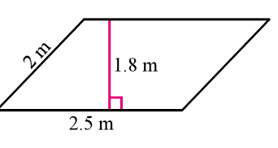

1. Find the area of the given trapezoid.

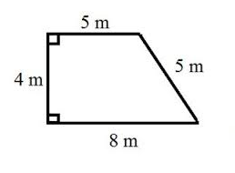

1. Represent a length of the square root of 8 on the geoboard.
2. Represent a length of 2 on the geoboard.
3. Is a triangle with side lengths 3,4,5 a right, acute, or obtuse triangle? Why?
4. Is a triangle with side lengths 6, 7, 10 a right, acute or obtuse triangle? Why?
5. Is a triangle with side lengths 9, 14, 15 a right, acute or obtuse triangle? Why?
6. Determine if the 3 side lengths form an acute, right or obtuse triangle. Also determine if you were to move one of the legs could you form a right triangle?
7. 7, 23, 25
8. 9, 15, 17
9. 5,10,13
10. Find the areas of the given shapes on the geoboard.
11. 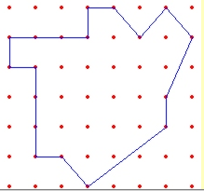
12. 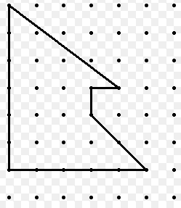
13. A graph of a line is shown below. 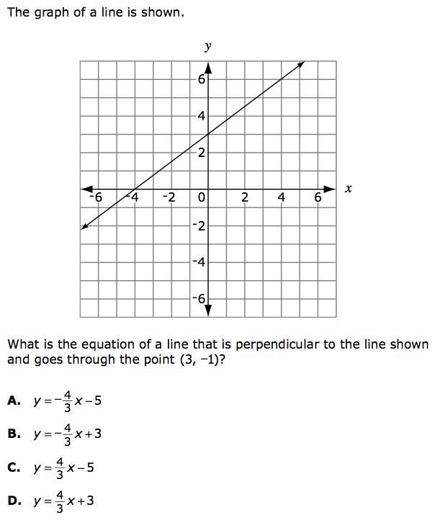

 What is the equation of a line that is perpendicular to the line shown and goes through the point (3, -1)?



1. A rectangle is drawn on a coordinate grid. The equation for 1 side of the rectangle is 3x – 2y = 12. Which could be an equation for another side of the rectangle?

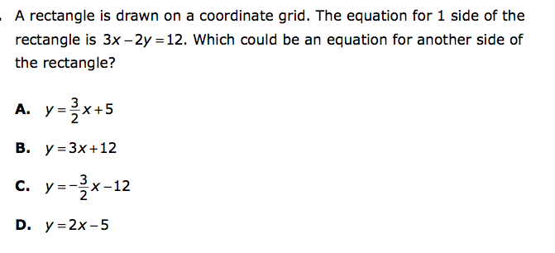

1. What quadrilateral is formed by the following four equations?

y = -x + 2 -2x + 2y = -12 x + y  = 8 y = x + 4

1. Which are the coordinates of the vertices of a parallelogram?

A  (-3, 2), (-1, 3), (2, 2), (0, 1)

B  (4, 1), (3, 5), (0, -2), (3, 3)

C  (-2, 1), (-3, 2), (-4, 3), (1, 1)

D  (0, 0), (1, 2), (6, 2), (4, 0)

Discover Pick’s formula

**Objective**: Be able to find the area of irregular shapes.

(2 day)

**Standards:** NCTM problem solving standard

**Launch:** If I wanted to carpet a room that was not a regular shaped room how could I find the area to know how much carpet I need?

**Explore:** Every student needs a Geoboard or Geoboard paper. Students need to make some kind of shape and find the area. Have students switch geoboards with their partner and have them check each other’s area. On the board make a table that has the number of border pegs in one column, the number of inside pegs in another, and the area in the 3rd column. Have students record their data Students will then make an intense shape and try to find the area, total pegs, border pegs, and inside pegs. Have a classmate check your shape and you check theirs. Students then need to write their data on the board so their classmates can see it. Students should be trying to find a relationship between the area, total pegs, border pegs, and inside pegs. Once your data is on the board look at your classmates data as well and see if you can come up with some type of formula to get the area of your shape faster than just counting the area.

**Share:** Every student will come and put their data on the board. Students will share their thinking in coming up with a formula to find the area of irregular shapes.

**Summarize:** Hopefully after quite awhile of class discussion and students going back and forth we can come up with the formula A = B/2 + I – 1 I would then tell students this is actually called Pick’s Formula.

**Analyze/Assess**

Making Line segments on the Geoboard

(1 day)

**Objective**: To figure out how to find all the measurement of all the line segments on a geoboard.

**Launch:** I have two horses and need two equal grass spots for them. Could you split your geoboard into 2 equal pieces? I also am going to need to build the horses a fence. I need you to help me figure out how much fencing I would need.

**Explore:** Students will start by cutting the geoboard in half. We will try to find all the possible ways to cut the geoboard in half. We also then need to find the perimeter of the horses grass spot so that we can find out how much fence we need. As students start working they notice that they struggle to find the length of some of the lengths of their sides. Before we can find the side lengths of some of the sides we decide to make a line segment and find its length. On the board we write the square roots of the numbers 1 – 30 on the board and see what line segments we can come up with. The only line segments we are able to find on a geoboard are the square roots of 1,2,4,5,8,9,10,16,17,18,20,25,32.

**Share:** Students will then show how they split their geobard into half and share what the perimeter of their horses grass space would be so that we could figure out how much fencing we would need.

**Summarize:** Students should see the difference between area and perimeter and real life examples of them. The grass space would be the area and the amount of fence would be the perimeter.

**Analyze/Assess:**

Classify Obtuse, Right and Acute Triangles

(2 day)

**Launch:** My brother-in-law just bought a house. They wanted to put new flooring down. They went to Home Depot to look for flooring. The flooring they wanted to buy the clerk said you need to make sure your floor is completely flat and all corners have exactly 90 degree angles. The house they bought was actually a barn turned into a house so they were not sure if the floor to the wall made a right angle. They thought their floor or their wall may be slanted a bit. They decided to measure. They leaned a 13 foot ladder up against the wall and measured the distance from the bottom of the ladder to the wall is 5 feet and the top of the ladder was at a point 10 feet up the wall. Can you determine if the wall and floor make a right triangle or what kind of triangle they do make?

**Explore:** Have students work in groups of 3. I student needs to draw an acute triangle and measure the side lengths. I student needs to draw an obtuse triangle and measure the side lengths and 1 person needs to draw a right triangle and measure the side lengths. Once each student has measured the side lengths of their triangle they need to fill in the chart below for each triangle. We put the chart on the board for students to fill in the information about their triangle. We would have a chart for the obtuse, right and acute triangles.

|  |  |  |  |  |  |
| --- | --- | --- | --- | --- | --- |
| A | B | C | A2 | B2 | C2 |
|  |  |  |  |  |  |
|  |  |  |  |  |  |
|  |  |  |  |  |  |
|  |  |  |  |  |  |

We then look for patterns or anything that we can see about the side lengths of the triangles.

**Share:** Students should start to notice that in the right triangle a2+b2=c2 , for an obtuse triangle a2+b2 is less than c2, and for an acute triangle a2+b2 is greater than c2.

**Explore:** Students will still be working in groups of 3. I am going to give you 3 side lengths. You need to help me decide what type of triangle the 3 side lengths would make. Then help me decide if I wanted to make sure all triangles were 90 degrees which leg would I need to change and would I make it more or less. Let’s start with the example with the floor from home depot at my brother-in-laws house. Side lengths of 5,10,13, what type of triangle do they form? Have students complete the worksheet attached labeled acute, right or obtuse triangle?

**Share:** Students will come up and share what they found for each of the 3 side lengths. The first one they did was 5,10,13. Students should notice this triangle is an obtuse triangle since 5 squared plus 10 squared is less than 13 squared. Students also needed to figure out how they could make this a right triangle. Students noticed that they could make the 10 a 12 and now 5 squared plus 12 squared equaled 13 squared. Students will continue to share the rest of their answers.

**Summarize:** To answer my brother-in-laws question he does not have 90 degree angles. His floor and or wall are not straight up and down. He will need to find a new kind of flooring to look at. The Pythagorean theorem is something that all of you may use at some point in your life. Depending on your job you may use it everyday. My husband’s uncle is a masonry down in Pequot Lakes he uses the Pythagorean theorem every day for his job.

**Analyze/Assess:**

Finding the Area formula for a parallelogram and a trapezoid.

(1 day)

**Standard:** 6.3.1.2Calculate the area of quadrilaterals. Quadrilaterals include: squares, rectangles, rhombuses, parallelograms, trapezoids, and kites. When formulas are used, be able to explain why they are valid.

**Objective:** Students will discover the formula to find the area of a parallelogram and a trapezoid

**Explore:** We are going to use a 1 by 1 cm as a unit of area measure. With a partner construct a parallelogram with scissors and paper. Knowing nothing about triangles find the area of a parallelogram. Students do know the area of a rectangle formula.

**Share:** Students should be able to see that if they cut the triangle off on one side and add it to the other side it makes a rectangle. Students can then see that the formula for the area of a parallelogram is A = bh from what they know about the area formula of a rectangle.

**Explore:** Now have students construct a trapezoid with paper and scissors. How can I find the area of a trapezoid that will work for all trapezoids? Students may struggle on this one. After students have worked for a while it might be helpful to tell them to make another trapezoid that is exactly the same. This may help students find the area of a trapezoid.

**Share:** Students may start to see that they could put the trapezoids together to make a parallelogram. Have students come up to the document camera to explain what they found. It may help to label the top base b1 and the bottom base b2. Students should then see that to find the area you take (b1+b2) times the height and then divided by 2. You divide by two since you had two trapezoids together.

**Summarize:** Formulas are very useful to find the area of different shapes. They are hard to remember though. Sometimes seeing where they came from can help us remember what those formulas are! I would then have students write in their notes the area formula for a parallelogram and a trapezoid.

**Analyze/Assess:**

**Analyzing the Wheel of Theodorus using Square Roots**

**Objectives:**

* Introduce the concept of square root
* Understand square root geometrically, as the side length of a square with known area
* Learn the meanings of rational number and irrational number
* Estimate the values of square roots that are irrational numbers
* Estimate lengths of hypotenuses of right triangles

**Launch:**

Discuss the side length of the square with an area of 4 square units. What is the length of each side? How do you know your answer is correct? Introduce the concept of square root. What number multiplied by itself is 4? We say the square root of 4 is 2. A square root of a number is a number that when squared, or multiplied by itself, equals the number. 2 is a square root of 4 because 2 x 2 = 4.

Is there another number you can multiply by itself to get 4? Introduce square root notation. Write $\sqrt{2}$ and the $\sqrt{2}$ on the board. Draw a square with an area of 2 square units on a dot grid. Ask: What is the side length of this square? Is it greater than 1? Is it greater than 2? Is 1.5 a good estimate for $\sqrt{2}$? Can you find a better estimate? When students understand the concept of square root, have them work on the problem in groups of two or three. Remind students that they should use a calculator only when the text asks them to do so.

Discuss how to find a decimal approximation for a square root.

On a dot grid, draw a square with an area of 2 square units on a number line, with the “bottom vertex” at point 0. Ask: What is the length of a side of this square? If we mark off a segment on the number line with the same length as the side, where will the segment end? So, is approximately equal to 1.4. Is 1.4 exactly equal to $\sqrt{2}$? Suppose we try 1.41. Does 1.41 = $\sqrt{2}$? Try 1.42. Does it equal $\sqrt{2}$? Can you find a number that is closer to $\sqrt{2}$ than 1.41 and 1.42 are? Display the Wheel of Theodorus. Explore with the class how the wheel was constructed and ask for the lengths of the second and third hypotenuses. Cut out the number-line ruler and demonstrate how to transfer these lengths to the ruler. Distribute Labsheet 4.1 and scissors to each student and have students work in groups of two to four on the problem

**Explore:**

Ask students how they know their answers for Questions A and B are correct. Ask them how they could check their answers. Ask students to find the negative square roots of 1, 9, 16, and 25 as well. Check their work to see if they are using the square root symbol correctly. Ask that each student label his or her own number-line ruler. Check on students’ understanding of measuring lengths and writing decimals.

**Summarize:**

 Talk about the side length of the square with an area of 2 square units. How can you prove that the area of this square is 2 square units? What is the exact length of a side of this square? You estimated by measuring a side of the square. What did you get? Is this the exact value of $\sqrt{2}$? You also found by using the square root key on your calculator. What value did your calculator give? Enter this number into your calculator and square it. Is the result exactly equal to 2? Emphasize that the results found by measuring and with a calculator are only approximate values for $\sqrt{2}$. Ask students for decimal approximations for $\sqrt{2}$. As a class, use a calculator to square each approximation to check whether the result is 5.

Display the Wheel of Theodorus. Ask for the lengths of the hypotenuses and write them on the wheel. Then, have students come to the front and mark the length of each hypotenuse on the number-line ruler. Ask for approximations to the nearest tenth for each length. As a class, check each approximation by squaring it on a calculator. Ask: Is this estimate too large? Too small? What might be a better estimate? How do you know? Take this opportunity to assess students’ understanding of the ordering of decimals. Ask students to compare their estimates to the numbers they obtained with a calculator. Tell the class that the numbers $\sqrt{2}, \sqrt{3}, and \sqrt{5}$ are irrational numbers.

The Wheel of Theodorus begins with a triangle with legs 1 unit long and winds around counterclockwise. Each triangle is drawn using the hypotenuse of the previous triangle as one leg and a segment of length1 unit as the other leg. To make the Wheel of Theodorus, you need only know how to draw right angles and segments 1 unit long.

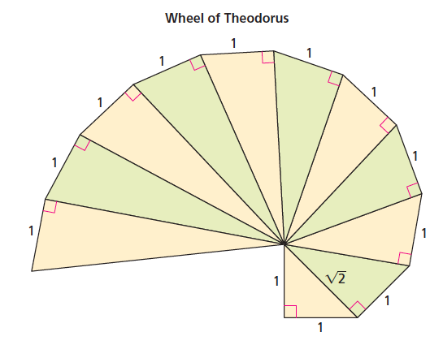

1. Use the Pythagorean Theorem to find the length of each hypotenuse in the Wheel of Theodorus, label each hypotenuse with its length. Use the square-root symbol to express lengths that are not whole numbers.
2. 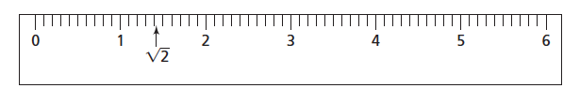Use a cut-out copy of the ruler below to measure each hypotenuse on the wheel. Label the place on the ruler that represents the length of each hypotenuse. For example, the first hypotenuse length would be marked like this:
3. For each hypotenuse length that is not a whole number:

1. Give the two consecutive whole numbers the length is between. For example, is between 1 and 2.

2. Use your ruler to find two decimal numbers (to the tenths place) the length is between. For example is between 1.4 and 1.5.

3. Use your calculator to estimate the value of each length and compare the result to the approximations you found in part (2).

1. Jared uses his calculator to find He gets 1.732050808. Greta says this must be wrong because when she multiplies 1.732050808 by 1.732050808, she gets 3.000000001.Why do these students disagree?

**Measuring the Egyptian Way**

**Objectives:**

* Determine whether a triangle is a right triangle based on its side lengths
* Relate areas of squares to the lengths of the sides

**Launch:**

Discuss the two questions in the introduction to Problem 3.4. Remind students that, so far, they have learned that if a triangle is a right triangle, then its side lengths satisfy the relationship $a^{2}+b^{2}=c^{2}.$ However, they do not yet know whether a triangle whose side lengths satisfy this relationship must be a right triangle. Have students work on the activity in the Getting Ready in pairs, or do the activity as a demonstration. Distribute rulers and straws, string, or polystrips, and have the class work in pairs on the problem.

**Explore:**

If necessary, help students form one of the triangles in Question A. If you have students who need more practice checking whether three side lengths form a right triangle, you might make up a few examples for them. Challenge some students to think about the multiples of side lengths of 3-4-5 and 5-12-13, such as 6-8-10 and 10-24-26. Ask: Do triangles whose sides have these lengths form a right triangle as well? How do you know? You could also challenge some students to find different sets of whole-number side lengths that make a right triangle (Pythagorean Triples).

**Summarize:**

Have someone demonstrate how to arrange the string, straws, or polystrips to form a triangle with side lengths 3 units, 4 units, and 5 units and to explain how he or she knows it is a right triangle. Explain that this triangle is sometimes called a “3-4-5 right triangle.” Are multiples of a 3-4-5 triangle, such as 6-8-10 and 9-12-15 triangles, also right triangles? Have students demonstrate each set of lengths on a grid at the overhead, checking for right angles with an angle ruler or a corner of a piece of paper. What about the multiples of 5-12-13? Do these lengths form a right triangle? Also, discuss the side lengths that did not form a right triangle. Which of these sets of side lengths did not form a right triangle? Does $a^{2}+b^{2}=c^{2}$ for these sets?

In ancient Egypt, the Nile River overflowed every year, flooding the surrounding lands and destroying property boundaries. As a result, the Egyptians had to remeasure their land every year. Because many plots of land were rectangular, the Egyptians needed a reliable way to mark right angles. They devised a clever method involving a rope with equally spaced knots that formed 12 equal intervals. To understand the Egyptians’ method, mark off 12 segments of the same length on a piece of rope or string. Tape the ends of the string together to form a closed loop. Form a right triangle with side lengths that are whole numbers of segments.

• What are the side lengths of the right triangle you formed?

• Do the side lengths satisfy the relationship $a^{2} + b^{2} = c^{2}$?

• How do you think the Egyptians used the knotted rope?

1. Use string, straws, or polystrips to build a triangle with the given side lengths. Then, complete the second and third columns of the table.

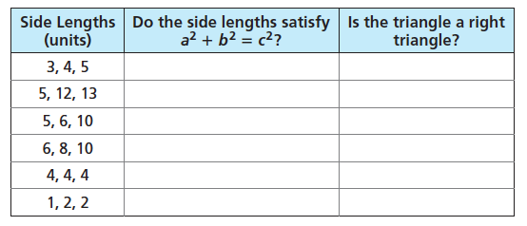

1. 1. Make a conjecture about triangles whose side lengths satisfy the relationship .

2. Make a conjecture about triangles whose side lengths do not satisfy the relationship .

3. Check your conjecture with two other triangles. Explain why your conjecture will always be true.

1. Determine whether the triangle with the given side lengths is aright triangle

1. 12 units, 16 units, 20 units

2. 8 units, 15 units, 17 units

3. 12 units, 9 units, 16 units

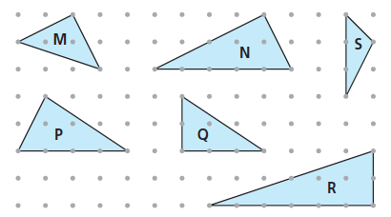D. Which of these triangles are right triangles? Explain.

**A Proof of the Pythagorean Theorem**

**Objectives:**

* Reason through a geometric proof of the Pythagorean Theorem

**Launch:**

Explain to the class that there are many proofs of the Pythagorean Theorem. One is based on the puzzle they will explore in this problem. Display a set of puzzle pieces on the overhead. Ask students if they see any relationships among the puzzle pieces. Your task is to arrange the puzzle pieces in the two frames and to look for a relationship among the areas of the three square pieces. Have students work in groups of four on the problem. Give each student scissors and a copy of Labsheet 3.2A.

**Explore:**

Encourage each group to find more than one way to fit the puzzle pieces into the two frames. Make sure each group compares its results with those of another group. Pass out a new set of puzzle pieces (Labsheets 3.2B and 3.2C) for some groups to explore.

**Summarize:**

When groups have finished the problem, ask about any general patterns they noticed. Demonstrate these relationships at the overhead. Have groups show how they arranged their puzzle pieces. What relationship do these completed puzzles suggest? Help students understand the following argument: The areas of the frames are equal. Each frame contains four identical right triangles. If the four right triangles are removed from each frame, the area remaining in the frames must be equal. That is, the sum of the areas of the squares in one frame must equal the area of the square in the other frame. Show a diagram of the completed puzzles with sides labeled a, b and c. Use the diagram to help students see the symbolic form of the Pythagorean

Theorem: $a^{2}+b^{2}=c^{2}$. Offer an example to help them apply the theorem. How can you use the Pythagorean Theorem to find the length of the hypotenuse of a right triangle?

Check for Understanding -

Draw two right triangles on the board. One should have legs labeled 6 and 2, and hypotenuse labeled “?”. The other should have legs labeled 4 and “?”, the hypotenuse labeled 7. Ask students to find the unknown lengths.

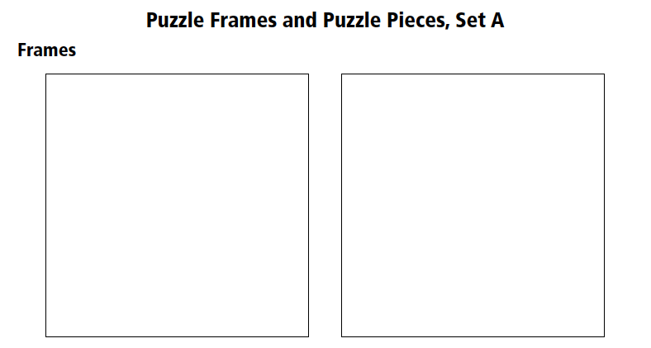

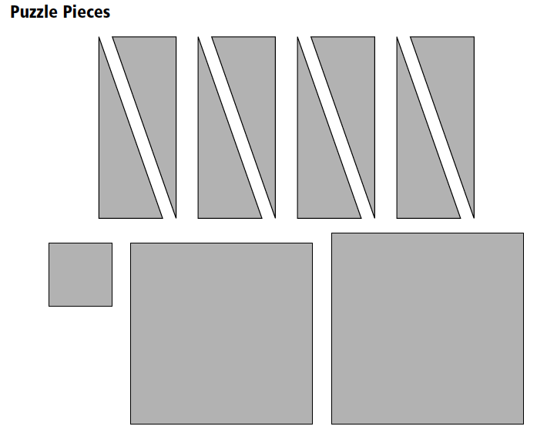

**Stopping Sneaky Sally**

**Objectives:**

* Estimate lengths of hypotenuses of right triangles
* Apply the Pythagorean Theorem to a problem situation

**Launch:**

Introduce the baseball scenario described in the Student Edition. Talk about the layout of a baseball diamond, which is pictured on Transparency 4.2. The baseball diamond is a square. Does anyone know the distance between bases on a standard baseball field? How far do you think a catcher would need to throw the ball to get a runner out at second base? Let students offer a few estimates, and then have them work in pairs on the problem.

**Explore:**

Some students may need help in recognizing the right triangles that are the key to solving the problem. Suppose you draw a line segment from home plate to second base. What is special about the line segment? What do you know about the side lengths of this right triangle? How can you find the length of the hypotenuse? Repeat these questions, if necessary, for Question B

**Summarize:**

Have several students share their strategies for solving the problem. Look for specific references to the Pythagorean Theorem. Stress the correct procedure: Square each leg length first, add the squares, and then take the square root of the sum to get the length of the hypotenuse.

Horace Hanson is the catcher for the Humboldt Bees baseball team. Sneaky Sally Smith, the star of the Canfield Cats, is on first base. Sally is known for stealing bases, so Horace is keeping an eye on her. The pitcher throws a fastball, and the batter swings and misses. Horace catches the pitch and, out of the corner of his eye, he sees Sally take off for second base. Use the diagram to answer Questions A and B.

1. How far must Horace throw the baseball to get Sally out at second base? Explain.
2. The shortstop is standing on the baseline, halfway between second base and third base. How far is the shortstop from Horace?
3. The pitcher’s mound is 60 feet 6 inches from home plate. Use this information and your answer to Question A to find the distance from the pitcher’s mound to each base.

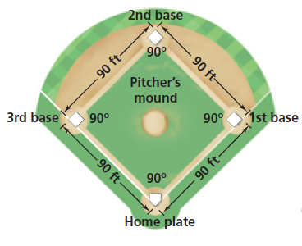

**Discovery of the Pythagorean Theorem**

(2 Days)

**Objective:** To discover the area interpretation of the Pythagorean Theorem.

**Launch**: Teacher will instruct the class that today we are going to do an investigation of triangles, specifically right triangles.

Activity 1: Have students draw a triangle with sides 2, 3, and 4 inches.

Then have students draw (try) a triangle with sides 2,3, and 5 inches.

**Explore**: Have them try several other possible combinations of lengths of sides of triangles.

**Share**: Have them share what has to be true in order to have a triangle.

Summary: This would be an appropriate time to share the statement “The shortest distance between two points is a straight line.”, and explain how this is related to whether or not a triangle exists.

Activity 2:

Teacher will instruct and model for students to start with (this can be done on a geoboard if desired);

**Explore**:

1. On a piece of graph paper go to the vertex and use the $90°$ angle to form a right triangle that has either 3 by 4, or 6 by 8, or 5 by 12 sides (use a ruler for straight edges).
2. Label the hypotenuse (longest side) c, and the other two, one a, and one b. then cut out the triangle.



1. Take the triangle and line a side of the triangle up with a line on the remaining graph paper, use that as the length of each side to form a square. Repeat this with each of the three sides.

Note: (the hypotenuse is will be either a 5 or 10 or 13 respectively from above, but the students will not know this. Remind them to use the graph paper to measure the hypotenuse, then they can square the length.)



1. When they are finished they are finished with all three sides, they should have three squares.



1. After students have completed their squares, have them give some conjectures about the possible relationships between the three square. They should eventually come to the conclusion that $a^{2}+b^{2}=c^{2}$.
2. Have the discuss what operations you would have to use if you knew two of the three squares, and wanted to find the third. i.e. the two smaller but not the larger, or the largest and one of the smaller but not the other.
3. Have them discuss if the same technique works if you know two of the three sides of a right triangle.
4. Have them discuss what they could do if they knew two of the three sides of a right triangle and needed to find the third. i.e. the two smaller segments but not the larger, or the larger and one of the smaller but not the third.

**Share:** Have students share The Pythagorean Theorem and techniques for solving for a missing side of a right triangle.

Activity 3 Show them a “Liquid Proof” of the Pythagorean Theorem via YouTube. <https://www.youtube.com/watch?v=CAkMUdeB06o#t=16.626656>

**Summary**: Have students describe how to know if a triangle exists, have them describe how to solve for the third side of a right triangle when given two other sides, and have them describe how they know that the Pythagorean Theorem is true.

The Scarecrow Postulate

(1 DAY)

**Objective:** To show that the Pythagorean Theorem does not work for non-right triangles.

**Launch**: Have students watch a clip from the Wizard of OZ from you tube about the Scarecrow’s math mistake. <https://www.youtube.com/watch?v=uCOxU2rKLas>

Activity 1

(Teacher may need to show this a few times) Have students write down what exactly the Scarecrow said after receiving his diploma. “The sum of the square roots of any two sides of an isosceles triangle is equal to the square root of the remaining side.”

**Explore**: Have students investigate this statement using the same method as the previous day when rediscovering the Pythagorean Theorem. They may need to review what an isosceles triangle is.



Some students may come up with this: If not teacher can cover that this as a possibility.



**Share**: Have students share their conclusions about the “Scarecrow Postulate”.

**Summarize**: That it can only work if the isosceles triangle is a $45° 45°90°$.

Converse of the Pythagorean Theorem

(1 DAY)

**Objective:** To be able to describe whether a triangle is obtuse, acute, or right based off of the Pythagorean Theorem.

**Review**: How we know if a triangle exists, how to solve for any side of a right triangle when two sides are known. Did the “Scarecrow Postulate” work?

**Launch**: In looking at the “Scarecrow Postulate” we saw that the Pythagorean Theorem does not work for the triangles with any length sides. How do know if the angle is greater than $90°$ (obtuse) or less than $90°$ (acute)?

**Explore**:

Activity 1

Have students create on graph paper an obtuse triangle, and explore what the relationship is, when the sides of the triangle are squared.

Have students create on graph paper an acute triangle, and explore what the relationship is, when the sides of the triangle are squared.

Activity 2

Have students use inequalities to describe the relationship $a^{2}+b^{2} ? c^{2}$ for obtuse triangles.



Have students use inequalities to describe the relationship $a^{2}+b^{2} ? c^{2}$ for acute triangles.



**Share/Summarize**: The Converse of the Pythagorean Theorem, and how we can tell if the angle is less than/greater than/ or equal to a right angle.

History of the Pythagorean Theorem

(1 DAY)

**Objective:** To understand some historical applications of the Pythagorean Theorem and its Converse, then apply the Pythagorean Theorem and its Converse.

**Launch:**

Show a video of on YouTube about the history of the Pythagorean Theorem. <https://www.youtube.com/watch?v=PrjTkWGLk2Q&list=PL-29HfakqajBS33k8Rv20nUbsoe-uB6pj>

After video, teacher will describe the history of how the Pythagorean Theorem (prior to Pythagoras) was used in Egypt by stretching ropes for both surveying of farm land next to the Nile river (when the land markers would get washed away each spring by floods), and during construction of the pyramids (the steps were filled in later, but they kept the steps perpendicular and the same size by using the ropes).





Teacher will explain that the Pythagorean Theorem (Converse) is still used today by construction workers to create right corners when building a structure.



**Explore:**

Teacher will have the students get in groups of 3 or 4 with string and a tape measure. (Teacher can tie knots prior to activity or have student’s problem solve a way to achieve equally spaced knots.) Teacher will than ask students to find a way to layout an $8 knot×10 knot$ dimension for a shed. You can also skip the knots and just use tape measures in feet. Teacher will instruct the class that the opposite sides have to be equal, and that they need to ensure that the corners are perpendicular.



**Share:** Have students share their difficulties and successes.

**Summary:** Wrap up the Pythagorean Theorem and the Converse of the Pythagorean Theorem.

Jim’s Yard-Grade 8

Objectives: Geometry & Measurement-taken from the Minnesota State Academic Standards

*Teachers direction or answers are given in parenthesis ().

*Prerequisite Knowledge: How to find slope of a line, plotting, labeling, and finding an ordered pair.

**Launch:**

Jim lives in Polygon Place and is a part time mechanic and keeps his extra pieces of cars, motors, tires, etc. everywhere around his house. He just received a letter in the mail about the new restriction that will need to be in place by the end of the month. Because he has so much junk lying around the neighbors are complaining. Here is a picture of Jim’s yard.

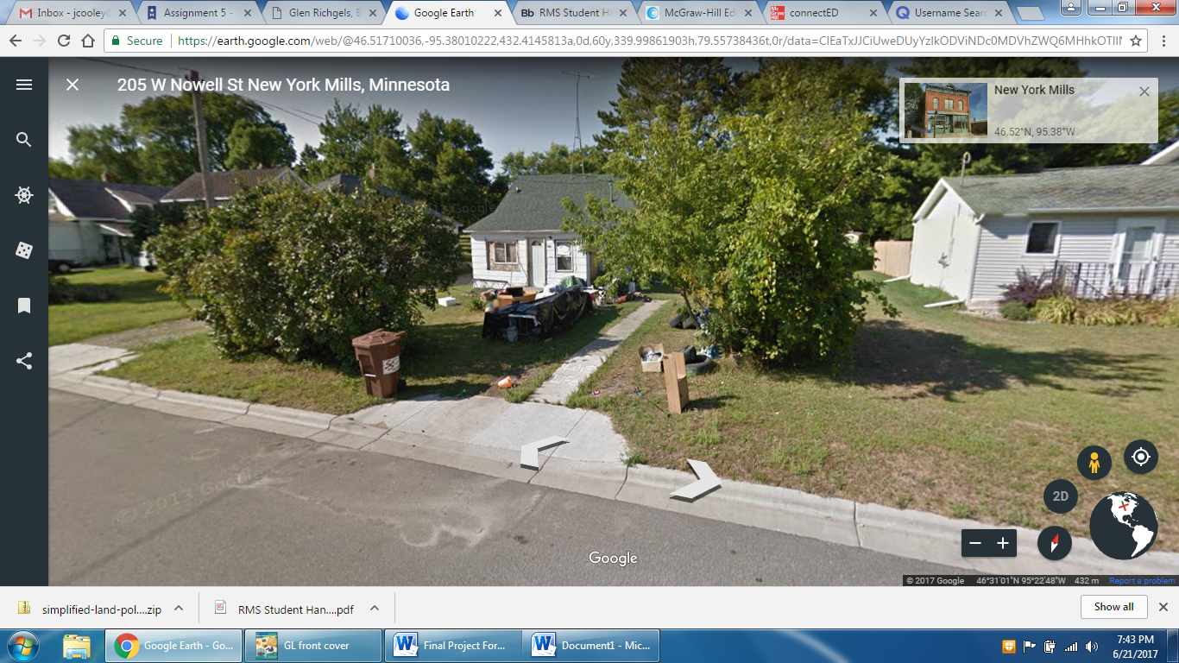 Image taken form Googleearth.com

Restriction: You either keep your yard clean or put up a fence surrounding your property.

Since all properties in Polygon Place are shaped like squares, Jim needs to find out the total amount of fence, in feet, he needs to purchase. In Jim’s letter, his property is placed on a grid. His property is in the bottom right corner of the red diagram. The board of Polygon Place needs Jim to respond by saying he will clean up his yard, or show with a drawing (drawn to scale) what his plans are.

Here is the drawing the board sent with where the vertical and horizontal axes are measured in feet.

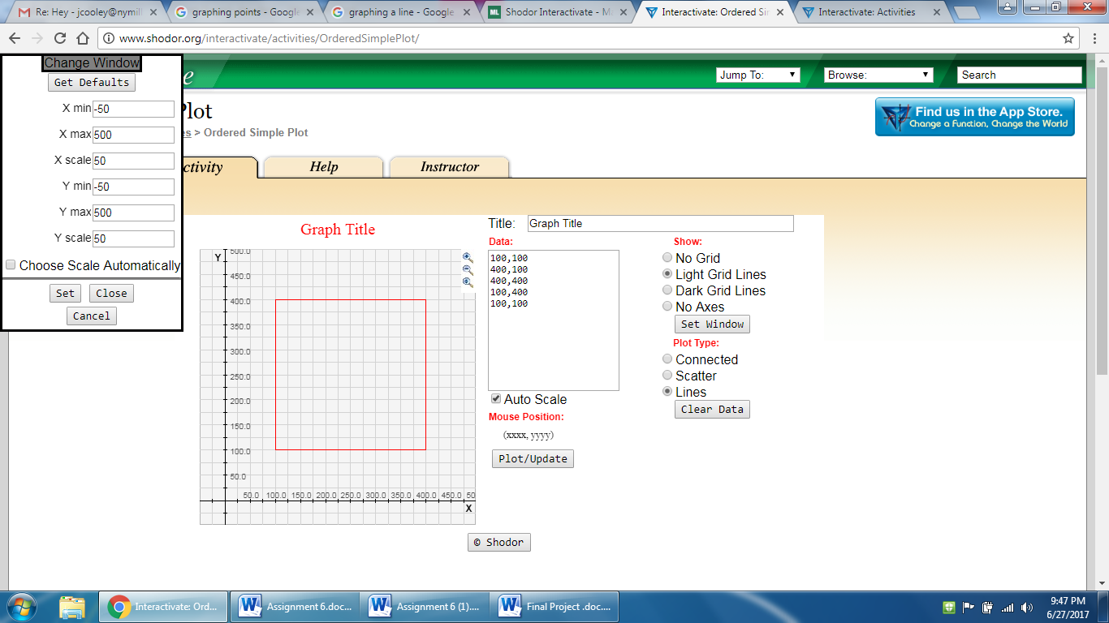

Your assignment:

1. Use the geo boards to make this sketch. How do you define each one of the pegs on the board? (sample: each peg represents a 5 ft by 5 ft square)
2. How do you know this is a square? (sample: all the sides are the same and the angles are 90 degrees)
3. What is the length of each of the four sides? (100 feet by 100 feet)
4. What is the perimeter of the square? (100 feet X 4 = 400 feet)
5. What is the total amount of fencing Jim needs to order? (400 feet)

**Explore/Share Day 1:**

Working with a partner, let’s change the shape of your property and let’s make your square a rectangle like the one shown below.

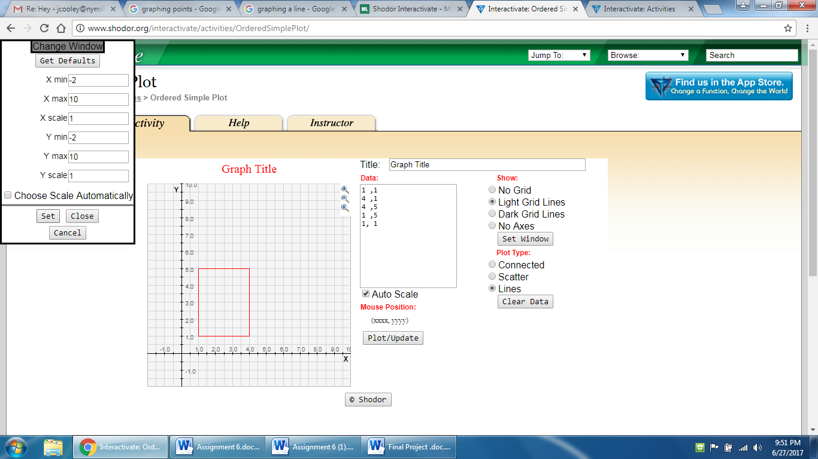

1. If your geoboard was a coordinate grid that was 5 by 5, what would be your four ordered pairs? (sample: (1 ,1 ) (4 ,1 ) (4 ,5 ) and (1 ,5 ))
2. On a piece of graph paper, copy your rectangle over. Let’s start on the bottom left and go around our rectangle in a clockwise motion and label each of the ordered pairs starting with A, then B, C, and D. What are these points called on a rectangle? (vertices)
3. Let’s recall what the slope of a line is. Slope is the vertical change divided by the horizontal change or rise over run. What is the slope of each of the sides of your rectangle? (segment AB = 1/0 or undefined, but we want the numbers in this case; segment BC = 0/1; segment CD = 1/0; and segment DA = 0/1)
4. On your geoboards, let’s change the shape of your rectangle to make a rectangle that doesn’t have a slope of zeros and ones. Make sure one side of the rectangle is longer than the other. Draw out your new rectangle on graph paper. Why must this direction be mentioned? (Otherwise the shape would be a square)
5. What are your new ordered pairs?(answers will vary)
6. What are things you notice about a rectangle (what must make this shape a rectangle)? (sample: it must have four sides with two sets of two opposite sides parallel and the angles are 90 degrees, which brings us to the next question)
7. What is the measure of each angle in a rectangle? (90 degrees) What quick tool can you use to help to make sure each angle is this measure? (the corner of a sheet of paper) Let’s recall what the slope of a line is. Slope is the vertical change divided by the horizontal change or rise over run. What is the slope of each of the sides of your rectangle? (answers will vary)
8. Using the diagram you drew, what is the slope of each side of your new rectangle?

Segment AB= ______________Segment BC= __________________

Segment CD = _____________Segment DA = __________________

Make sure your partner is finding the slope correctly. Give your slopes to the teacher who will place in a table to keep track for tomorrow. Write the slopes of each side on the board when you have them completed, making sure to reduce when possible. (Answers will vary, but walk around to make sure students are on the right track.)(The table should be clear enough for the students to see the segments AB, BC, CD, and DA at the top and fill in their slopes going down)

**Summarize:** After everyone is done giving their slopes to the teacher if time the teacher should show the students the data and see if the students can see anything in common or uncommon about the slopes of the sides and think about this tonight. You have done a lot of work today. Let’s review what we went through. First we looked at Jim’s yard and helped him figure out the perimeter. Next we drew out rectangles and found the slopes of the lines. Tomorrow, we will be investigating what happens with the slopes of these rectangles and how can we prove these are rectangles.

**Explore/Share Day 2:**

(Have all the students stand up and arrange students by birthday date and put in groups of 3. Bring up the table as the students are walking into the room and as students are getting into their groups, ask what they see in common or uncommon about all these slopes. On the board, write down the words, common, uncommon, and patterns. Then ask the question,” If I give you a new shape, would you be able to tell me if this shape is a rectangle, how?” Have the students work together for about 5-10 minutes until they start to see a pattern) Get back together as a big group and ask one person from each group write down something in each of the columns. Discuss for each column. (Students should be able to conclude that the opposite sides are parallel and you might need to assist them with the idea of perpendicular slopes. They should be able to see that the adjacent sides, which students know the angle is 90 degrees, have opposite reciprocal slopes, which means these two lines are perpendicular. Now let’s review what parallel and perpendicular means. Parallel lines have the same slope and perpendicular lines have opposite reciprocal slopes. Have the students write these definitions in their vocabulary notebooks for future keeping. A drawing of what parallel and perpendicular is always helpful for students along with some examples. What do these two definitions mean on your rectangle?)

(Now have the students look at their rectangles that they had made from yesterday and ask if they can prove that the opposite sides of their rectangle are parallel? Demonstrate this by having one student volunteer their rectangle and go through with a practice proof. Then ask the students to prove that the other two sides are parallel? Prove the adjacent (touching) sides are perpendicular? How? Walk around and make sure the students are showing the slopes are the same or opposite reciprocals of each other. When it seems that the students understand the definitions, have them recreate a new rectangle and hand it over to a partner and have the partner prove it is a rectangle. You can continue this for the remainder of the day. Wrap up by having the students try and stump the teacher with a rectangle that the teacher needs to prove.

**Explore/Share Day 3:**

Let’s review what we did yesterday. Draw a rectangle on the board with the points A (0,0), B (1,2), C (3,1), and D (2,-1) and ask for a volunteer to come up and prove this is a rectangle. Now, draw a shape on the board with the points A (0,0), B (1,2); C (5,2) and D (4,0). Have students get in groups of 3 by shoes size and figure out this shape. Is this shape a rectangle? No…why not?...Students should be able to see that opposite sides are not opposite reciprocals of each other, but opposite sides are parallel. Ask the student what kind of shape is this? After a quick discussion, review a couple of quadrilaterals, mainly a rhombus and a parallelogram. What properties do these two shapes have? The teacher can have a couple of students do a quick google search for the definitions of each of these: quadrilaterals, rhombus, and parallelogram. Then write each vocabulary word with a picture in their vocabulary notebooks.

Hand out the worksheet A

Give students about 5-10 minutes to work on this with a partner. After worksheet A students should be pretty familiar with the definitions of quadrilaterals. Hand out worksheet B and give the students the rest of the time in class to finish.

**Explore/Share Day 4 and 5:**

Correct worksheet B and answer any questions that arise. Hand out worksheet C and let students work by themselves first, then after 20 minutes they can work with a partner if necessary. Correct at the end of the hour.

Give out group and guided practice questions

**Summarize:** During these lessons, students learn how to graph quadrilaterals and prove whether the quadrilateral is a parallelogram. Through discovery students learn about parallel and perpendicular lines and how to apply this to squares, rectangles, rhombuses, and parallelograms.

Extension: Have students use the Pythagorean Theorem to find the side lengths of their rectangles. How can students determine this?

Worksheet A Name___________________

Answer the following questions

1. What do a square and a rhombus have in…

Common Uncommon

(two sets of parallel sides Different angle measures)

1. Is a square a rectangle? Yes or No (Yes)
2. What do a parallelogram and rectangle have in…

Common Uncommon

(two sets of parallel sides could have different angle measures

A rectangle is a parallelogram)

1. What does a parallelogram, square, rectangle, and rhombus all have in common?

(they are all quadrilaterals)

1. What needs to be true in order for a quadrilateral to be a parallelogram?

(two sets of parallel sides)

1. Is a rectangle a square? Yes or No (No)

Worksheet B (taken from Connected Mathematics 2) Name ________________________

On a copy of this diagram, draw quadrilaterals meeting the conditions in parts (a)–(d). Your figures should fit entirely on the grid and should not overlap.

1. Rectangle *ABCD* lies entirely in the second quadrant.
2. Rectangle *EFGH* lies entirely in the first quadrant.
3. Rectangle *PQRS* is not a square. It lies entirely in the third quadrant except for vertex *Q*.
4. Square *TUVW* lies entirely in the fourth quadrant.

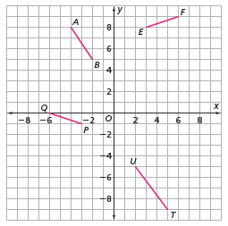

HINT:

1. Draw a coordinate grid, copy the segments, and label the 4 quadrants.
2. What is the relationship between the slopes of two sides that are perpendicular to each other? Use this fact to make perpendicular sides for the rectangles and squares.
3. What is the relationship of the slopes of two sides that are parallel to each other? Use this fact to make sure that the opposite sides of the rectangles and squares are parallel to each other.

Worksheet C (taken from Connected Mathematics 2) Name___________________________

The quadrilaterals named in parts 1-4 are parallelograms formed on the diagram below. Give the coordinates of the fourth vertex. Then, calculate the slopes of the sides to show that the opposite sides are parallel.

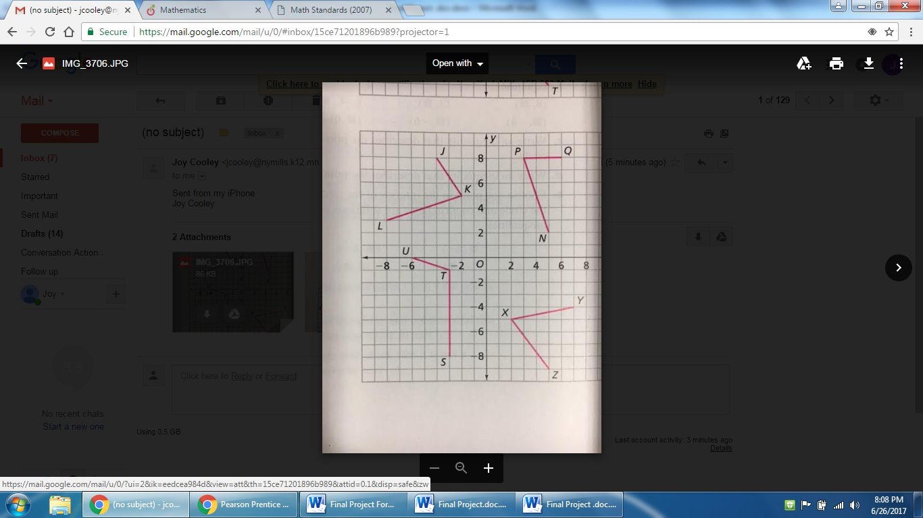

1. JKLM 2. NPQR 3. STUV 4. WYXZ

Group and Guided Practice

Find the equation of a line parallel to the given line.

5. y = -3x + 5

6. y = -2/3x -4

7. y = 2x + 3 and goes through the point (6,2)

8. y = ½ x -12 and goes through the point (1, -2)

Find the equation of a line perpendicular to the given line.

1. y = -3x + 5

1. y = -2/3x -4
2. y = 2x + 3 and goes through the point (6,2).

12. Which are the coordinates of the vertices of a parallelogram?

A  (-3, 2), (-1, 3), (2, 2), (0, 1)

B  (4, 1), (3, 5), (0, -2), (3, 3)

C  (-2, 1), (-3, 2), (-4, 3), (1, 1)

D  (0, 0), (1, 2), (6, 2), (4, 0)

Citations

Connected Math Project, 8th grade

Connected Mathematics 2

MCA Sampler 2